Mavilor Motors S.A.
Polígon Industrial Can Bernades i Sobirà
C/ Empordà 11-13
08130 Santa Perpètua de Mogoda, Spain
25.03.2025

ENVIRONMENTAL AND QUALITY POLICY

MAVILOR MOTORS, S.A. is committed to providing products and services that meet the highest standards of quality and environmental responsibility while ensuring safety and health at its facilities. This commitment is based on the principles of continuous improvement and efficient management, in line with the requirements of UNE-EN-ISO 9001:2015 i UNE-EN-ISO 14001:2015, ATEX (2014/34/EU), ISO/IEC 80079-34:2018, UKEx (UKSI 2016:1107, amended by UKSI 2019:696). Additionally, we strictly comply with applicable legal and regulatory frameworks and the requirements defined by our customers.
With extensive experience and industry knowledge, MAVILOR MOTORS, S.A. offers high-value solutions for motion control applications in robotics, mechatronics, and industrial automation. Our commitment to quality and sustainability has positioned us as a global reference in the servo motor market.
Our mission is to develop innovative and sustainable solutions in servo motors and actuators, ensuring optimal efficiency while minimizing environmental impact. Our vision is to become the reference supplier for machinery manufacturers and designers, providing products that meet the highest standards in quality and sustainability.
To achieve these objectives, we ensure customer satisfaction by implementing a quality and environmental management system based on continuous improvement, pollution prevention, and the efficient use of natural resources.
The entire organization actively participates in quality and environmental management, promoting best practices and fostering a culture of responsibility and commitment.
Management assumes ultimate responsibility for these commitments and ensures the availability of the necessary human, productive, and financial resources to achieve them, while also ensuring continuous training and employee engagement.
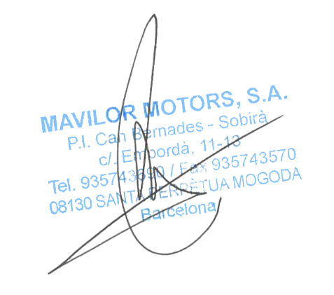

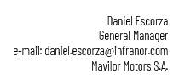

Joan Sierra
Quality and Environmental Manager
e-mail: joan.sierra@infranor.com
Mavilor Motors S.A.

